Isosceles Right Triangle
# Source: AI Source: Provided by: [Data Path: Persons Table -> ID Column: 1, Name_En Column: Motasem Essam] -> From: [ChatGPT] on [7/25/2026]
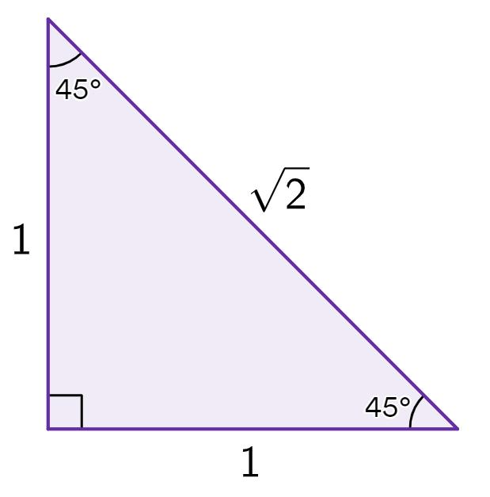
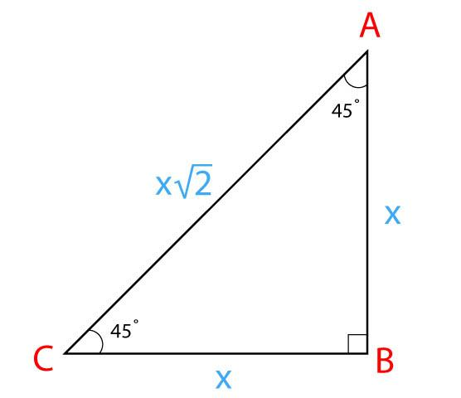
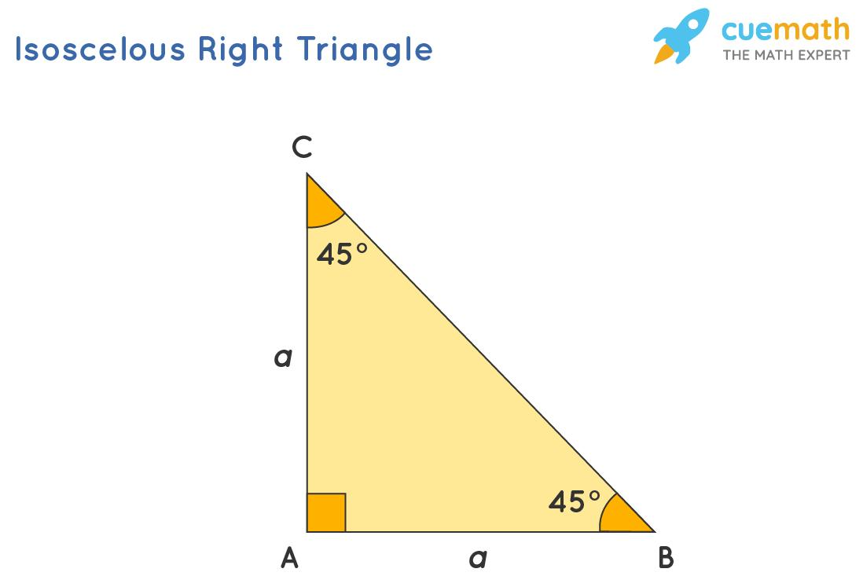
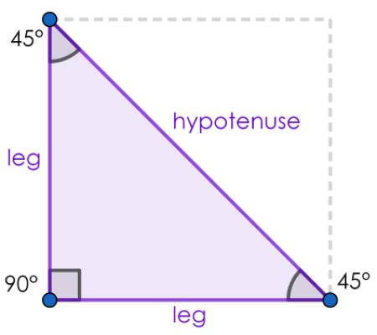
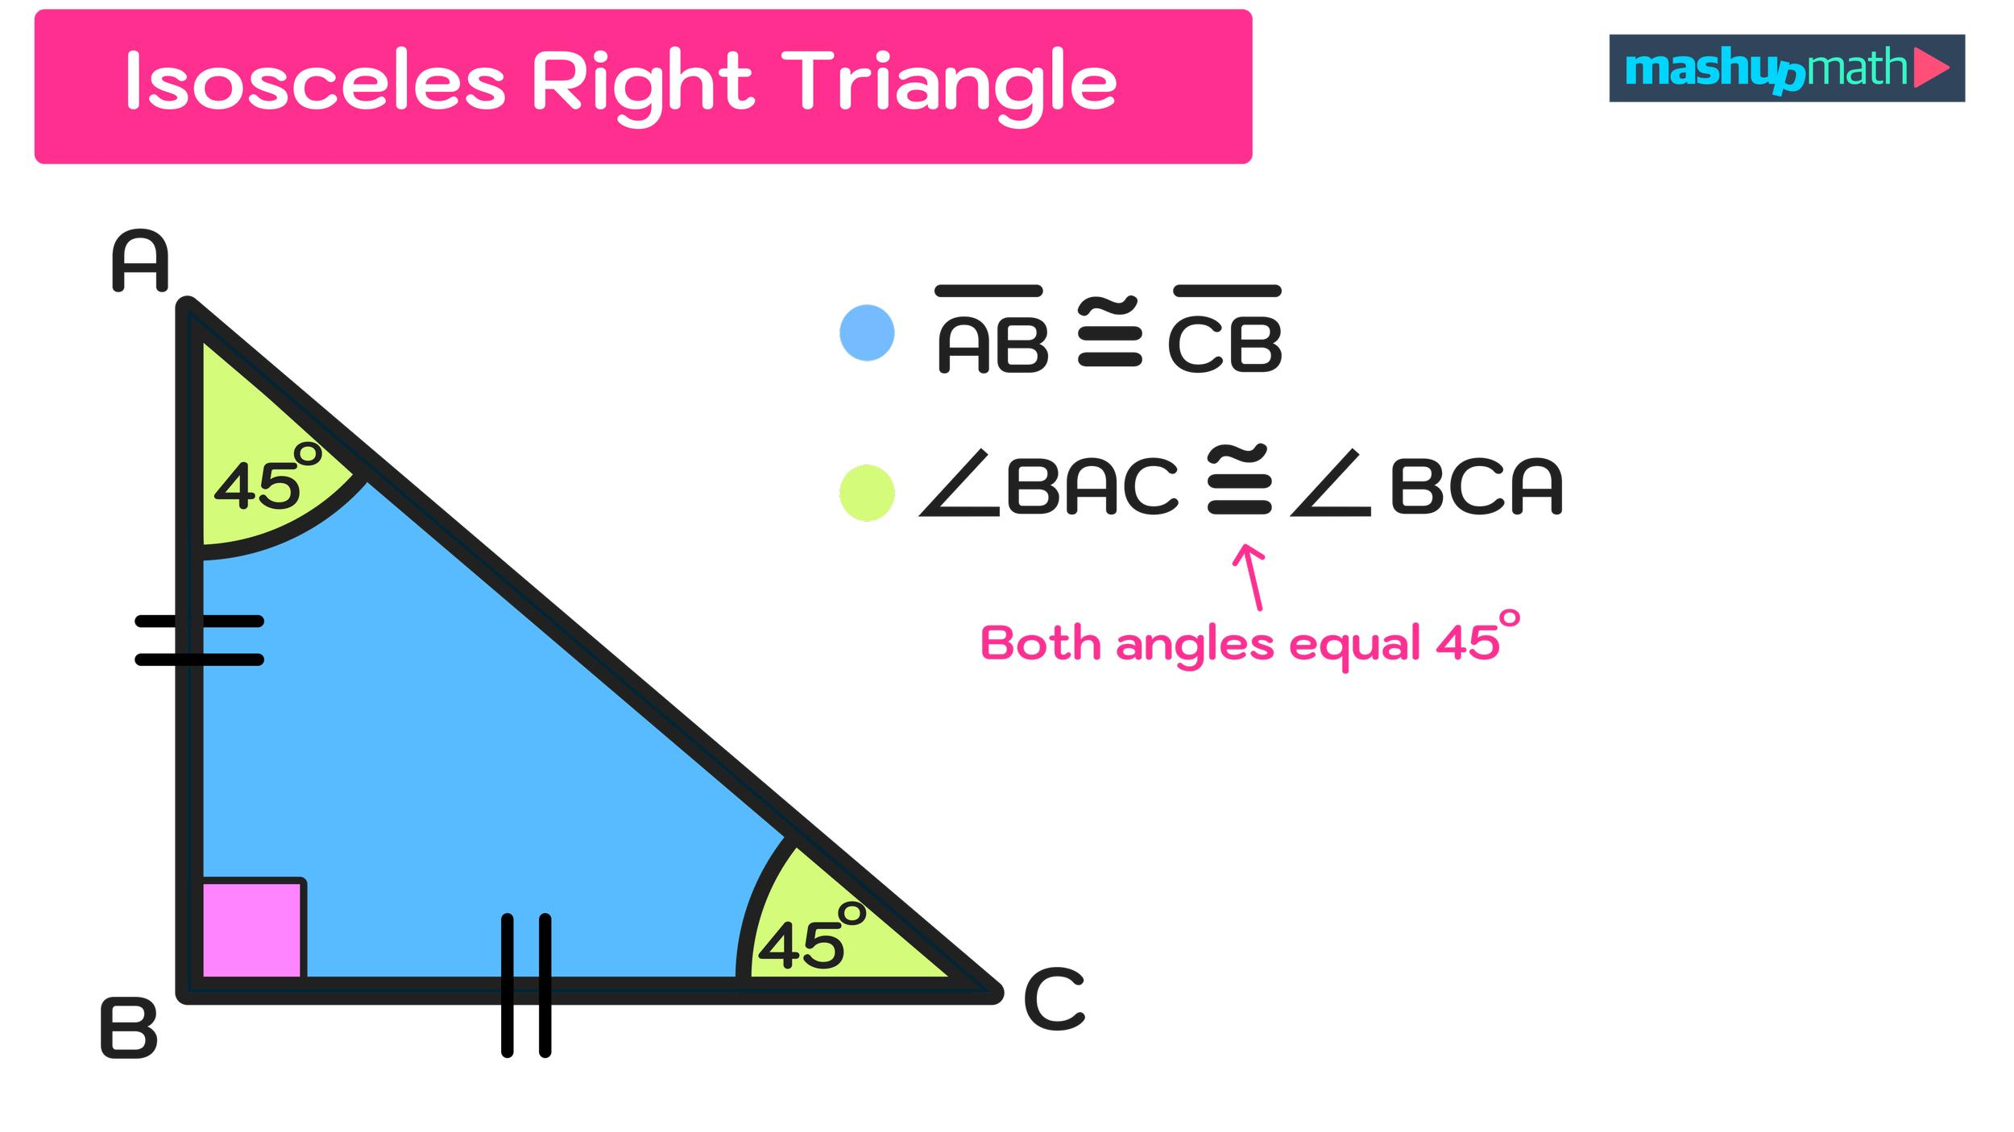

Definition
# Source: AI Source: Provided by: [Data Path: Persons Table -> ID Column: 1, Name_En Column: Motasem Essam] -> From: [ChatGPT] on [7/25/2026]
An Isosceles Right Triangle is a triangle that is classified simultaneously:
- By sides: Isosceles — two sides are equal.
- By angles: Right — one angle is exactly ${90}^{∘}$.
The two equal sides are necessarily the legs of the right triangle.
For triangle $ABC$, if:
$$\boxed{AC=BC}$$
and:
$$\boxed{∠C={90}^{∘}}$$
then $△ABC$is an isosceles right triangle.

Classification
# Source: AI Source: Provided by: [Data Path: Persons Table -> ID Column: 1, Name_En Column: Motasem Essam] -> From: [ChatGPT] on [7/25/2026]
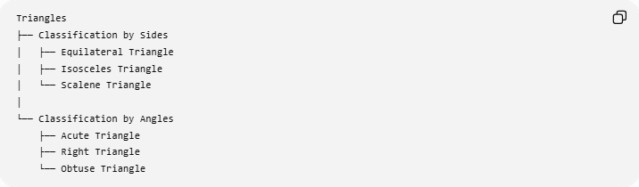
Triangles
├── Classification by Sides
│ ├── Equilateral Triangle
│ ├── Isosceles Triangle
│ └── Scalene Triangle
│
└── Classification by Angles
├── Acute Triangle
├── Right Triangle
└── Obtuse Triangle
The combined classification is:
Classification by Sides and Angles
└── Isosceles Right Triangle
It is the unique standard triangle type having:
$$\boxed{2\text{ equal sides}+1\text{ right angle}}$$

Fundamental Properties

1. Two Equal Sides
# Source: AI Source: Provided by: [Data Path: Persons Table -> ID Column: 1, Name_En Column: Motasem Essam] -> From: [ChatGPT] on [7/25/2026]
The two legs are equal:
$$\boxed{a=b}$$

2. One Right Angle
# Source: AI Source: Provided by: [Data Path: Persons Table -> ID Column: 1, Name_En Column: Motasem Essam] -> From: [ChatGPT] on [7/25/2026]
The angle between the equal legs is:
$$\boxed{{90}^{∘}}$$

3. Two Equal Acute Angles
# Source: AI Source: Provided by: [Data Path: Persons Table -> ID Column: 1, Name_En Column: Motasem Essam] -> From: [ChatGPT] on [7/25/2026]
Since the two remaining angles are equal and the angles of a triangle sum to ${180}^{∘}$:
$$\frac{{180}^{∘}-{90}^{∘}}{2}={45}^{∘}$$
Therefore:
$$\boxed{{45}^{∘}, {45}^{∘}, {90}^{∘}}$$
This is known as the ${45}^{∘}-{45}^{∘}-{90}^{∘}$triangle.

Side Ratio
# Source: AI Source: Provided by: [Data Path: Persons Table -> ID Column: 1, Name_En Column: Motasem Essam] -> From: [ChatGPT] on [7/25/2026]
The defining side ratio is:
$$\boxed{1:1:\sqrt{2}}$$
where:
- $1$= first leg
- $1$= second leg
- $\sqrt{2}$= hypotenuse
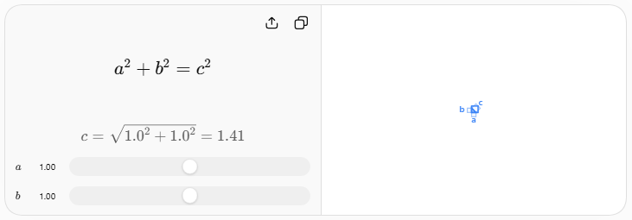
If each leg has length $a$, the hypotenuse is:
$$\boxed{c=a\sqrt{2}}$$
Conversely:
$$\boxed{a=\frac{c}{\sqrt{2}}=\frac{c\sqrt{2}}{2}}$$

Pythagorean Theorem
# Source: AI Source: Provided by: [Data Path: Persons Table -> ID Column: 1, Name_En Column: Motasem Essam] -> From: [ChatGPT] on [7/25/2026]
Because it is a right triangle:
$$\boxed{a^{2}+b^{2}=c^{2}}$$
Since:
$$a=b$$
we obtain:
$$a^{2}+a^{2}=c^{2} \\ 2a^{2}=c^{2}$$
Therefore:
$$\boxed{c=a\sqrt{2}}$$

Symmetry
# Source: AI Source: Provided by: [Data Path: Persons Table -> ID Column: 1, Name_En Column: Motasem Essam] -> From: [ChatGPT] on [7/25/2026]
An isosceles right triangle has one line of reflection symmetry.
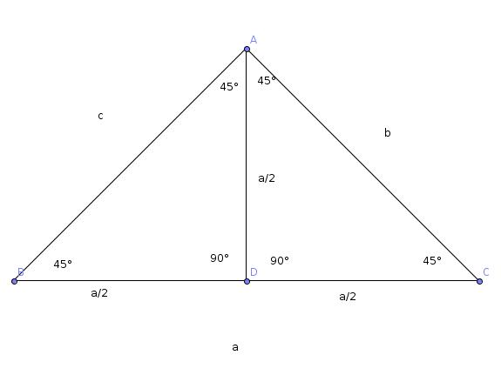
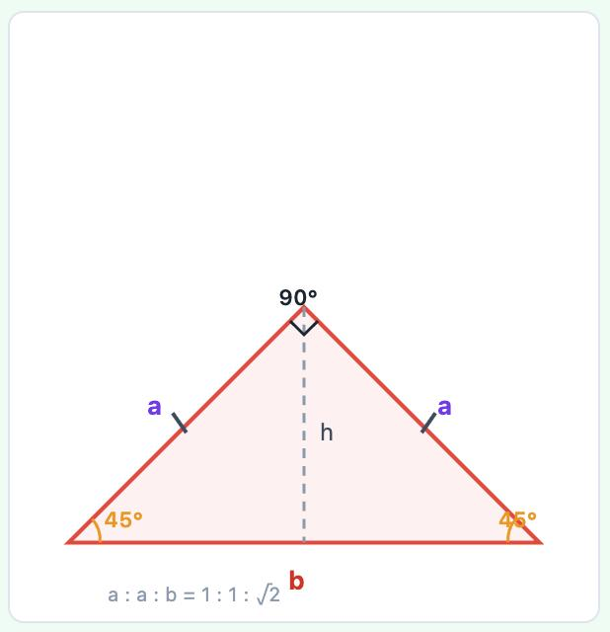
The symmetry axis:
- Starts at the ${90}^{∘}$vertex.
- Meets the midpoint of the hypotenuse.
- Is perpendicular to the hypotenuse.
- Bisects the ${90}^{∘}$angle.
Thus, it is simultaneously:
$$\boxed{\text{Median}} \\ \boxed{\text{Altitude}} \\ \boxed{\text{Angle Bisector}} \\ \boxed{\text{Perpendicular Bisector of the Hypotenuse}}$$

Angles
# Source: AI Source: Provided by: [Data Path: Persons Table -> ID Column: 1, Name_En Column: Motasem Essam] -> From: [ChatGPT] on [7/25/2026]
The three angles are always:
$$\boxed{{45}^{∘}, {45}^{∘}, {90}^{∘}}$$
The two ${45}^{∘}$angles are equal because the two legs are equal.
They are also complementary:
$$\boxed{{45}^{∘}+{45}^{∘}={90}^{∘}}$$

Area
# Source: AI Source: Provided by: [Data Path: Persons Table -> ID Column: 1, Name_En Column: Motasem Essam] -> From: [ChatGPT] on [7/25/2026]
If each equal leg has length $a$, the area is:
$$\boxed{A=\frac{1}{2}a^{2}}$$
Example
If:
$$a=6$$
then:
$$A=\frac{1}{2}{\left(6\right)}^{2} \\ \boxed{A=18}$$

Perimeter
# Source: AI Source: Provided by: [Data Path: Persons Table -> ID Column: 1, Name_En Column: Motasem Essam] -> From: [ChatGPT] on [7/25/2026]
The perimeter is:
$$P=a+a+a\sqrt{2}$$
Therefore:
$$\boxed{P=a\left(2+\sqrt{2}\right)}$$
Example
For $a=6$:
$$P=6\left(2+\sqrt{2}\right) \\ \boxed{P=12+6\sqrt{2}}$$

Height
# Source: AI Source: Provided by: [Data Path: Persons Table -> ID Column: 1, Name_En Column: Motasem Essam] -> From: [ChatGPT] on [7/25/2026]
The two equal legs are themselves perpendicular, so either one can be used as the base and the other as the height.
Therefore:
$$\boxed{h=a}$$
for a base chosen as one of the legs.
However, the altitude drawn from the ${90}^{∘}$vertex to the hypotenuse is different. The altitude to the hypotenuse is:
$$\boxed{h_{c}=\frac{a}{\sqrt{2}}=\frac{a\sqrt{2}}{2}}$$

Circumcenter
# Source: AI Source: Provided by: [Data Path: Persons Table -> ID Column: 1, Name_En Column: Motasem Essam] -> From: [ChatGPT] on [7/25/2026]
For every right triangle, the circumcenter is the midpoint of the hypotenuse.
Therefore, in an isosceles right triangle:
$$\boxed{O=\text{midpoint of hypotenuse}}$$
The circumradius is:
$$\boxed{R=\frac{c}{2}}$$
Since:
$$c=a\sqrt{2}$$
we get:
$$\boxed{R=\frac{a\sqrt{2}}{2}}$$

Orthocenter
# Source: AI Source: Provided by: [Data Path: Persons Table -> ID Column: 1, Name_En Column: Motasem Essam] -> From: [ChatGPT] on [7/25/2026]
The orthocenter of a right triangle is located at the vertex of the right angle.
Therefore:
$$\boxed{H=\text{right-angle vertex}}$$

Centroid
# Source: AI Source: Provided by: [Data Path: Persons Table -> ID Column: 1, Name_En Column: Motasem Essam] -> From: [ChatGPT] on [7/25/2026]
The centroid $G$is the intersection of the three medians.
Because the triangle is isosceles, $G$lies on the symmetry axis.
The centroid divides each median in the ratio:
$$\boxed{2:1}$$
measured from the vertex toward the opposite side.

Incenter
# Source: AI Source: Provided by: [Data Path: Persons Table -> ID Column: 1, Name_En Column: Motasem Essam] -> From: [ChatGPT] on [7/25/2026]
The incenter $I$is the intersection of the internal angle bisectors.
Because the triangle is isosceles:
$$\boxed{I\text{ lies on the symmetry axis}}$$
For an isosceles right triangle with leg $a$, the inradius is:
$$\boxed{r=\frac{a\left(2-\sqrt{2}\right)}{2}}$$

Four Principal Centers
# Source: AI Source: Provided by: [Data Path: Persons Table -> ID Column: 1, Name_En Column: Motasem Essam] -> From: [ChatGPT] on [7/25/2026]
The four principal triangle centers are:
- Centroid $G$
- Incenter $I$
- Circumcenter $O$
- Orthocenter $H$
In an isosceles right triangle:
$$\boxed{G, I, O, H\text{ are all on the symmetry axis}}$$
However, unlike an equilateral triangle:
$$\boxed{G≠I≠O≠H}$$
in general.

Euler Line
# Source: AI Source: Provided by: [Data Path: Persons Table -> ID Column: 1, Name_En Column: Motasem Essam] -> From: [ChatGPT] on [7/25/2026]
Because an isosceles right triangle is non-equilateral, it has an Euler line.
The circumcenter $O$, centroid $G$, and orthocenter $H$are collinear:
$$\boxed{O, G, H\text{ are collinear}}$$
The Euler line coincides with the triangle's symmetry axis.
The standard relationship remains:
$$\boxed{OG:GH=1:2}$$

Example
# Source: AI Source: Provided by: [Data Path: Persons Table -> ID Column: 1, Name_En Column: Motasem Essam] -> From: [ChatGPT] on [7/25/2026]
Consider an isosceles right triangle whose two equal legs have length:
$$a=5$$
Hypotenuse
$$c=5\sqrt{2} \\ \boxed{c=5\sqrt{2}≈7.071}$$
Angles
$$\boxed{{45}^{∘}, {45}^{∘}, {90}^{∘}}$$
Area
$$A=\frac{1}{2}\left(5\right)\left(5\right) \\ \boxed{A=12.5}$$
Perimeter
$$P=5+5+5\sqrt{2} \\ \boxed{P=10+5\sqrt{2}}$$
Circumradius
$$R=\frac{5\sqrt{2}}{2} \\ \boxed{R=\frac{5\sqrt{2}}{2}}$$

Coordinate Representation
# Source: AI Source: Provided by: [Data Path: Persons Table -> ID Column: 1, Name_En Column: Motasem Essam] -> From: [ChatGPT] on [7/25/2026]
A convenient coordinate representation is:
$$A=\left(0 , 0\right), B=\left(a , 0\right), C=\left(0 , a\right)$$
Then:
$$AB=a \\ AC=a$$
and:
$$BC=a\sqrt{2}$$
The right angle is at $A$:
$$\boxed{∠A={90}^{∘}}$$
The centroid is:
$$\boxed{G=\left(\frac{a}{3} , \frac{a}{3}\right)}$$
The circumcenter is:
$$\boxed{O=\left(\frac{a}{2} , \frac{a}{2}\right)}$$
and the orthocenter is:
$$\boxed{H=\left(0 , 0\right)}$$
Thus $O$, $G$, and $H$lie on:
$$\boxed{y=x}$$
which is the symmetry axis and Euler line.

Relationship with Other Combined Types
# Source: AI Source: Provided by: [Data Path: Persons Table -> ID Column: 1, Name_En Column: Motasem Essam] -> From: [ChatGPT] on [7/25/2026]
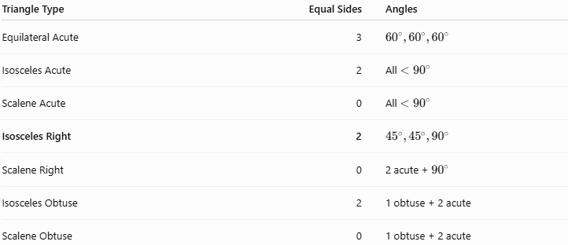
Triangle Type | Equal Sides | Angles
Equilateral Acute | 3 | $${60}^{∘},{60}^{∘},{60}^{∘}$$
Isosceles Acute | 2 | All $<{90}^{∘}$
Scalene Acute | 0 | All $<{90}^{∘}$
Isosceles Right | 2 | $${45}^{∘},{45}^{∘},{90}^{∘}$$
Scalene Right | 0 | 2 acute + ${90}^{∘}$
Isosceles Obtuse | 2 | 1 obtuse + 2 acute
Scalene Obtuse | 0 | 1 obtuse + 2 acute

Real-World Applications
# Source: AI Source: Provided by: [Data Path: Persons Table -> ID Column: 1, Name_En Column: Motasem Essam] -> From: [ChatGPT] on [7/25/2026]
Isosceles right triangles appear in:
- Square and rectangular construction
- Diagonal measurements
- Architecture
- Engineering
- Computer graphics
- Coordinate geometry
- Surveying
- Structural design
- 45-degree brackets and supports
A square can be divided along a diagonal into two congruent isosceles right triangles.

Key Points
# Source: AI Source: Provided by: [Data Path: Persons Table -> ID Column: 1, Name_En Column: Motasem Essam] -> From: [ChatGPT] on [7/25/2026]
- An Isosceles Right Triangle has two equal sides and one ${90}^{∘}$angle.
- The two equal sides are the legs.
- Its angles are always:
$$\boxed{{45}^{∘}, {45}^{∘}, {90}^{∘}}$$
- Its side ratio is:
$$\boxed{1:1:\sqrt{2}}$$
- If each leg is $a$:
$$\boxed{c=a\sqrt{2}}$$
- Its area is:
$$\boxed{A=\frac{1}{2}a^{2}}$$
- It has exactly one line of reflection symmetry.
- The symmetry axis is simultaneously a median, altitude, angle bisector, and perpendicular bisector of the hypotenuse.
- Its circumcenter is the midpoint of the hypotenuse.
- Its orthocenter is the right-angle vertex.
- Its centroid, incenter, circumcenter, and orthocenter all lie on the symmetry axis.
- The symmetry axis is also the Euler line.
- It is the standard ${45}^{∘}-{45}^{∘}-{90}^{∘}$special right triangle.

Conclusion
# Source: AI Source: Provided by: [Data Path: Persons Table -> ID Column: 1, Name_En Column: Motasem Essam] -> From: [ChatGPT] on [7/25/2026]
An Isosceles Right Triangle combines the defining properties of an isosceles triangle and a right triangle. Its two legs are equal, its third side is the hypotenuse, and its angles are necessarily ${45}^{∘},{45}^{∘},$and ${90}^{∘}$. Its distinctive $1:1:\sqrt{2}$ side ratio, single symmetry axis, and highly structured triangle centers make it one of the most important special triangles in geometry.

